NATURAL HERBS, NATURAL BEAUTY SURVEY
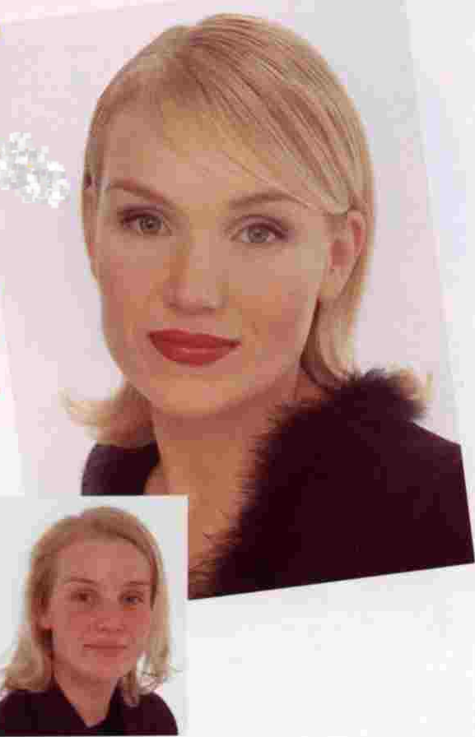

Are you concerned about the environment?
Yes? No?

Are you interested in your Appearance?
Yes? No?

Which of the words describe you best?
Natural? Vibrant?

Do you experience loss of vitality during the day?
Yes? No?

Are you concerned how a toxic environment can damage your skin?
Yes? No?

Do you believe that proper nutrition improves the quality of your skin?
“Such an amazing difference. Colour has totally transformed my image in less than ten minutes.”
Yes? No?

If you were to purchase skin care products, what would be your main concern?
Price? Not tested on animals? Allergy tested? Quality?
Natural Ingredients? Have a guarantee?

If we could help you with products that cover these issues, would you be interested?
Yes? No?

Would you (or a close friend or family) be interested in a Free Make-Over?
Yes? No?

Do you think how you look and feel affects your moods?
Yes? No?

Do you think how you look, affects your Performance for the day?
Yes? No?

Or, would you prefer information on safe and effective products being sent to you?
Yes? No?

Would you like to hear more about the business opportunity behind these incredible products?
A marketing plan second to none where you can become financially secure by developing a team on whom you can earn monthly royalties. Would you like a video information package?
Yes? No?

Name _________________________
Address ________________________
_________________ Code ________
Tel: ______________
E-Mail________________________

Entry into the prize draw is free.

Every third entry will win a
7 day free holiday for two with
To:
many locations to choose from!!
To enter, please post or fax your details
and your holiday voucher will be sent back
to you within 14 days.

Or for faster service, fax to:

